5道大题、5个算法

Topics:

Applied ML

Algorithms: Kernels, Perceptions, Naïve Bayes…

Mathematical formulas:

1. **Entropy**

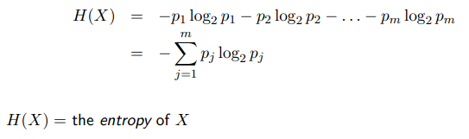

1. **MSE – Tutorial 3**

the mean squared error



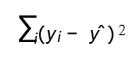

1. **B****ias-****Variance Decomposition - l11_Ensemble**
2. **Partial derivatives 偏导数**
3. **Gradient descent 梯度下降 - l04_NeuralNet p11-17**
4. **Gram matrix 格拉姆矩阵 - l06_KernelMethods**

